Improved wireframes discussion.
The feedback from the second assignment for wireframes was brief, going from this the wireframes are in good shape and show a general layout of what the website will consist off.
The wireframes did not discuss colour that will be used so incorporating colour will allow the visual aspect of the website to stand out more and have better structure layout. The colour can break apart the areas of the website that need to be outlined.
Using Canvas I created a logo that consists of a dark brown and red with a white background. Using the same colours from the logo I can add these colours to break the website into clear sections. I went with the dark red colour as the main colour using the brown colour as border colours. White is used for the text and hovering over any links will result in a change to the brown colour. This will help visually when seeing if something is a link.
Secondly, for the main section of the webpage I have made the content fit into a smaller area using CSS. This will help to ensure that content does not stretch or shrink depending on the screen size from the user. This adds security to the content and makes the website less likely to look strange if used on a different screen.
Removing the gallery from pages other than the home page will help user interaction, if the gallery is within these pages the user would have to scroll down each time the page was open resulting in confusion and unnecessary scrolling.
Lastly, I removed the customer reviews from the front page to limit the amount of content within the first page. Less is more in many cases, and I believe this is one of them. I also added boxes to break up the home page and label the content below creating an easier reading structure for the user.
The rest of the page stayed the same with the footer continuing using the same colour scheme as the header.
See images below.
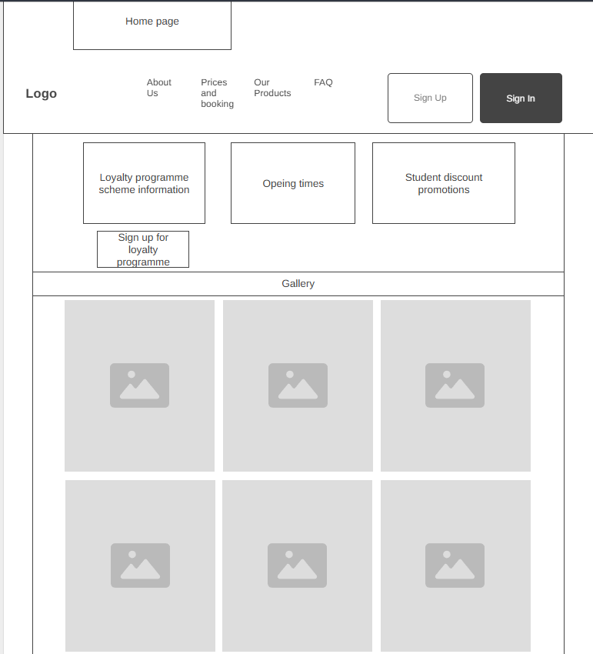
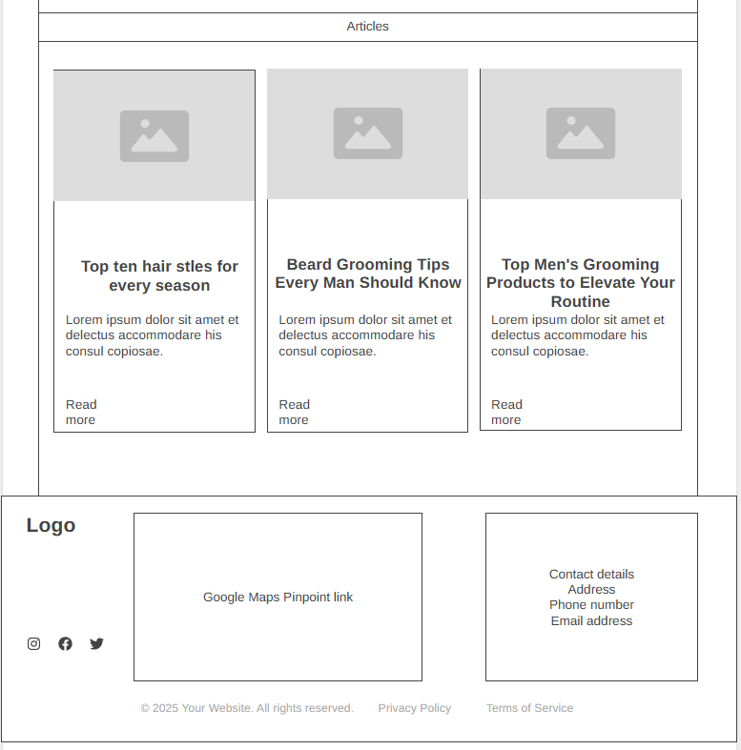

The second wireframe consists only of options for booking the correct haircut. This page is very simple and will just have the template layout plus the two options. Keeping this webpage simple is key for user experience so they do not get overwhelmed with choices and can make a quick and simple decision.
In our presentation we said that this page could be expanded to include more options but after review I believe the page can be kept simple with just two options to ensure the user is not overloaded with choice keeping the user engaged and satisfied.
See image below
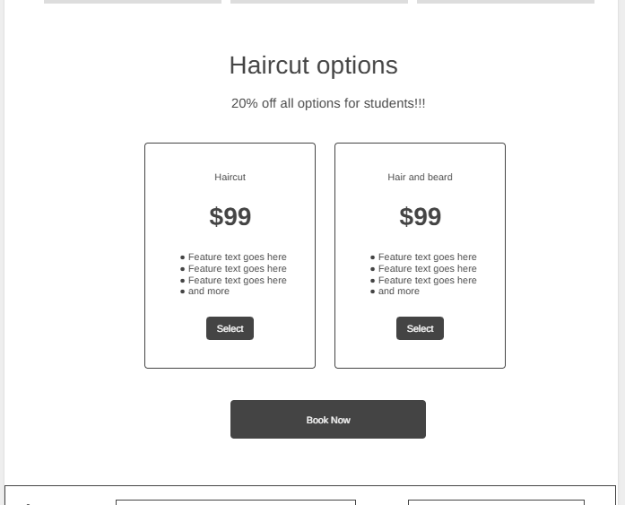

The last page spoke about within the presentation is the final stage of booking online. This is the remaining information required that would be necessary to book an appointment. I have decanted the information required and changed the discount message to appear at the bottom instead of in the middle of the form. This should help the flow when entering information and leaves the user to be able to read the student information if required.
Keeping this page simple is key for the fast-booking system we are aiming for. The user personas both require a booking online system, and this system would work for both cases, being fast for a busy user and easily accessible for other users.
See image below
